For the intersection at 52nd and Bedford Ave., changing the number of lanes would do little to nothing for the traffic. As the graphs below show.

This had an average weight time of 11.84 seconds, and the longest times was sixty-one seconds.

This one had an average wait time of 12.50 seconds, and the longest time was again sixty-one seconds.

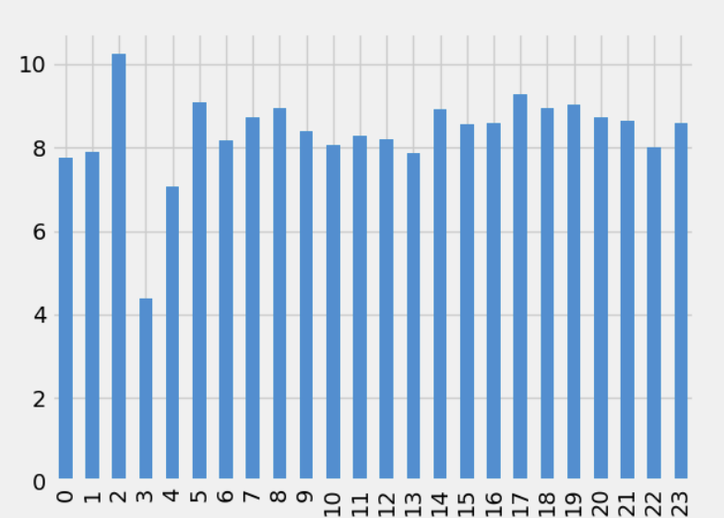One of the graphs above has four lanes and the other two, I can bet you would not be able to tell the difference. I believe that the thing that would change the weight time the most is the light times. It is also the most cost effective. When I did a wait time of thirty seconds and eighty seconds I found the lowest average weight time, even if there was an outlier with the wait time of eighty-one seconds. It will consistently have better wait times and cause less traffic.

The next topic to cover is the cost of changing the timing of the lights.

As you can see above, the cost of changing a light, though not cheap, is enough to make it reasonable to change it for the sake of people’s time. Making people spend more than 8.56 seconds I was able to accomplish with more time given to the North-South transit and less to the East-West.

The upfront cost may seem unappealing but long term, if more people can get to the places, they need quicker, they spend more money at places and less time in traffic.

When,

it is no wonder that many people in Omaha do not want to go out often. But the fix is simple. Changing the wait time could be out with the old, at least at 52nd and Bedford Ave. and in with the new.

The last thing to talk about is assumptions made in my model. My model likely does not take into account how busy it is in the morning as 52nd and Bedford is the home to not one but two separate schools. 52nd and Maple has Benson High School and 52nd and Bedford has Monroe Middle School, these two buildings together cause mass traffic two times a day like clockwork. This traffic experiment would not know that and therefore would not take into account the wait times of 7am-8am and 3pm-4pm all week. If there was the chance to take into account how busy those two times are I think the data would be even more telling of what should happen.

The data right next to this is from the experiment that consistently had the lowest times and only had one jump in wait time.

I find it interesting that the times are so evenly spread, this means that the number of cars was evenly spread between the hours and therefore does not properly show what the real-life situation looks like.

As someone who lives near that street, I can promise that at 7am-8am and 3pm-4pm, the wait times go way up. The light at 52nd and Bedford Ave. also sometimes stops working going East-West and makes it almost impossible to get a green light without waiting at least ten minutes, something that was also not taken into account.

The simulation also did not take into account sensor lights. These are the lights that change based on if they can sense a vehicle in an area. That is not a problem on 52nd and Bedford Ave. as there is no sensor there, but I am sure that the idea of a sensor could also greatly affect that as well.